Experiment 6
Aim: Blockchain platform Ethereum using Ganache.
Activity:

Step1: Install and setup Ganache
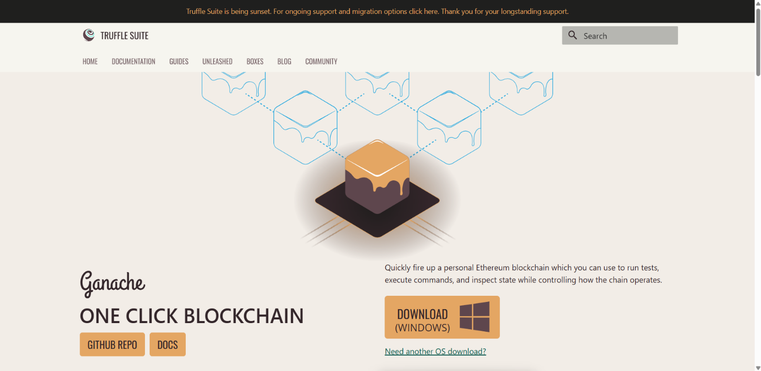

Step 2: Go to quick start and get ready to use setup
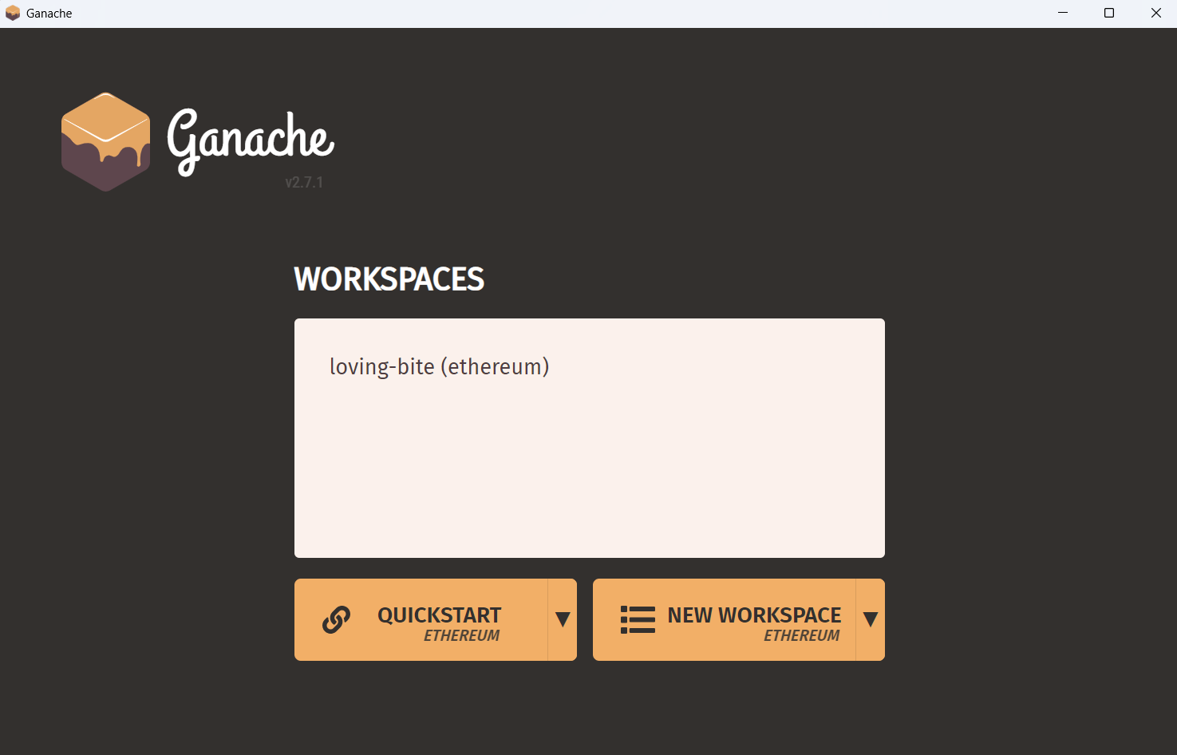
Step 3: Found the account credentials and RPC URL details in dashboard
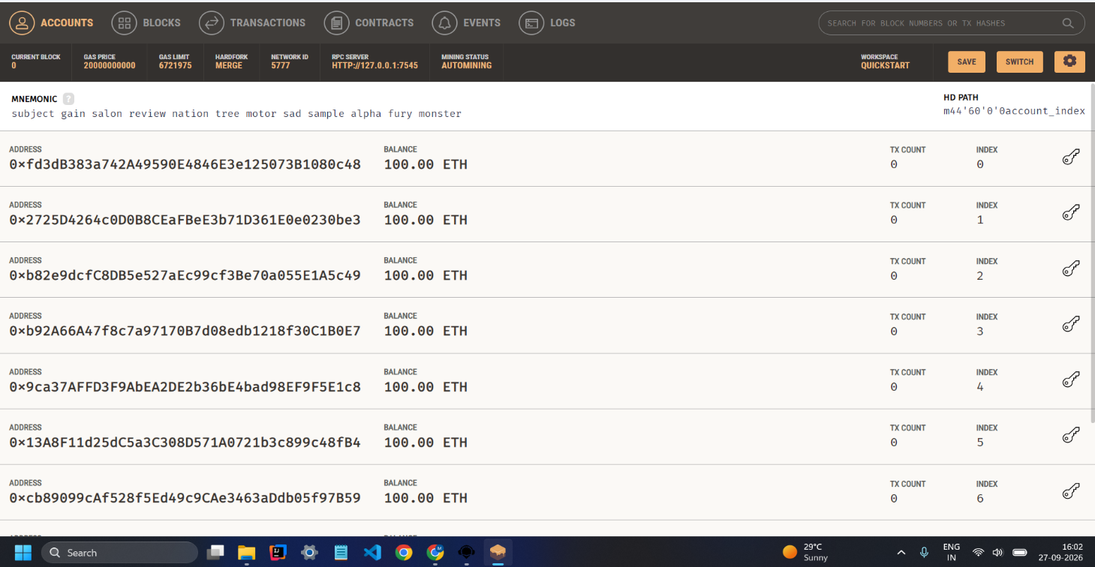

Step 4: Open Remix IDE and create an contract
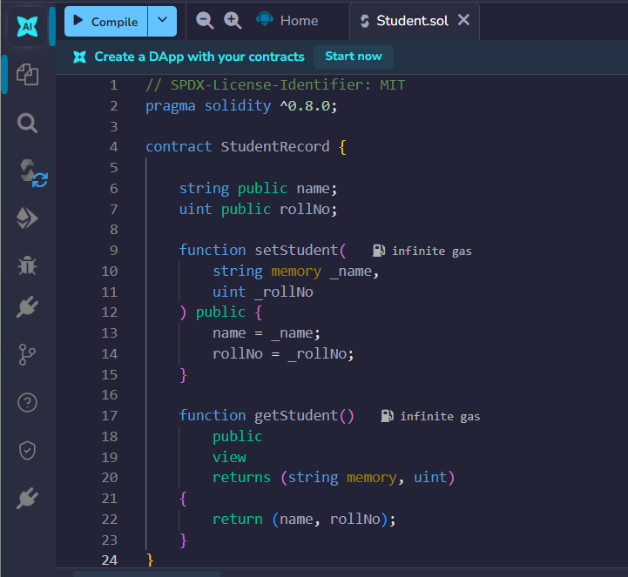
Step 5: Go to compile and deploy and use the RPC URL given in Ganache and for connecting with it
- Select Environment Dev
- Then provider as Ganache Provider
- Then in URL use Ganache provided URL
- Then click on Ok to connect with Ganache index 0 account

Step 6: Compile and deploy your contract using the RPC
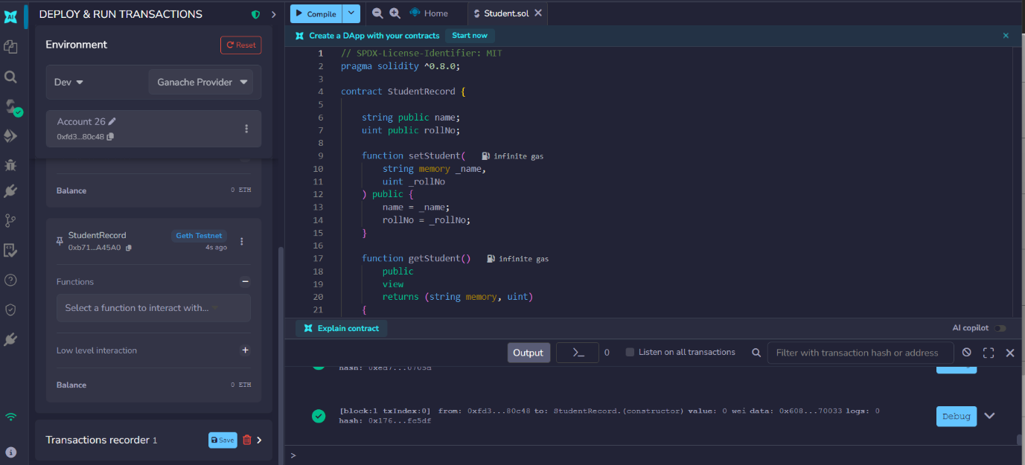

Step 7: Use function and make transaction , See blocks for transaction blocks and transaction each transaction being done through IDE in Ganache

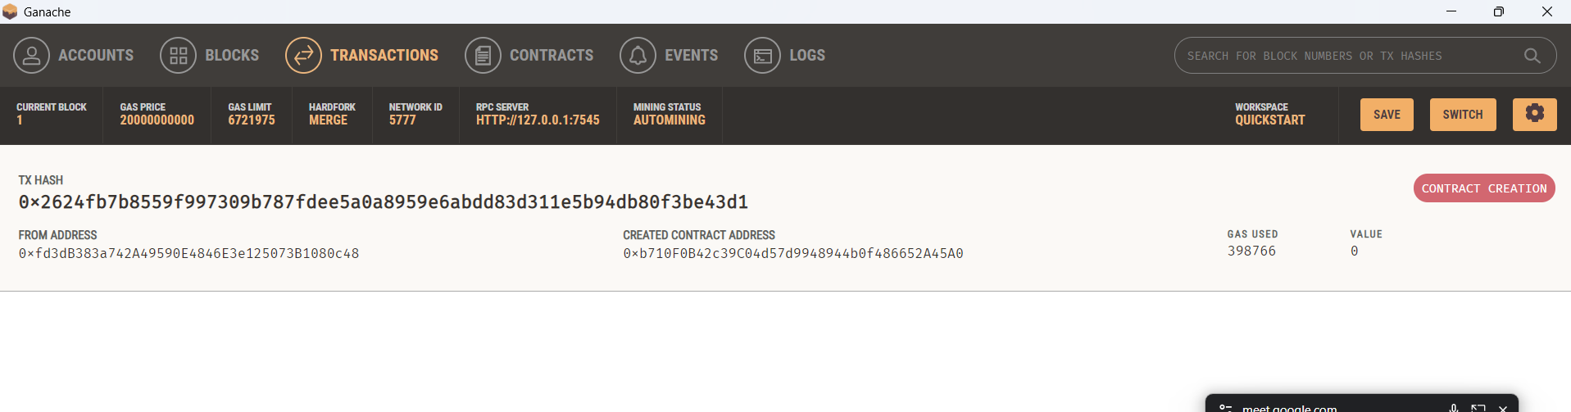
Step 8: Perform transaction and function call.
setStudent function call
1)
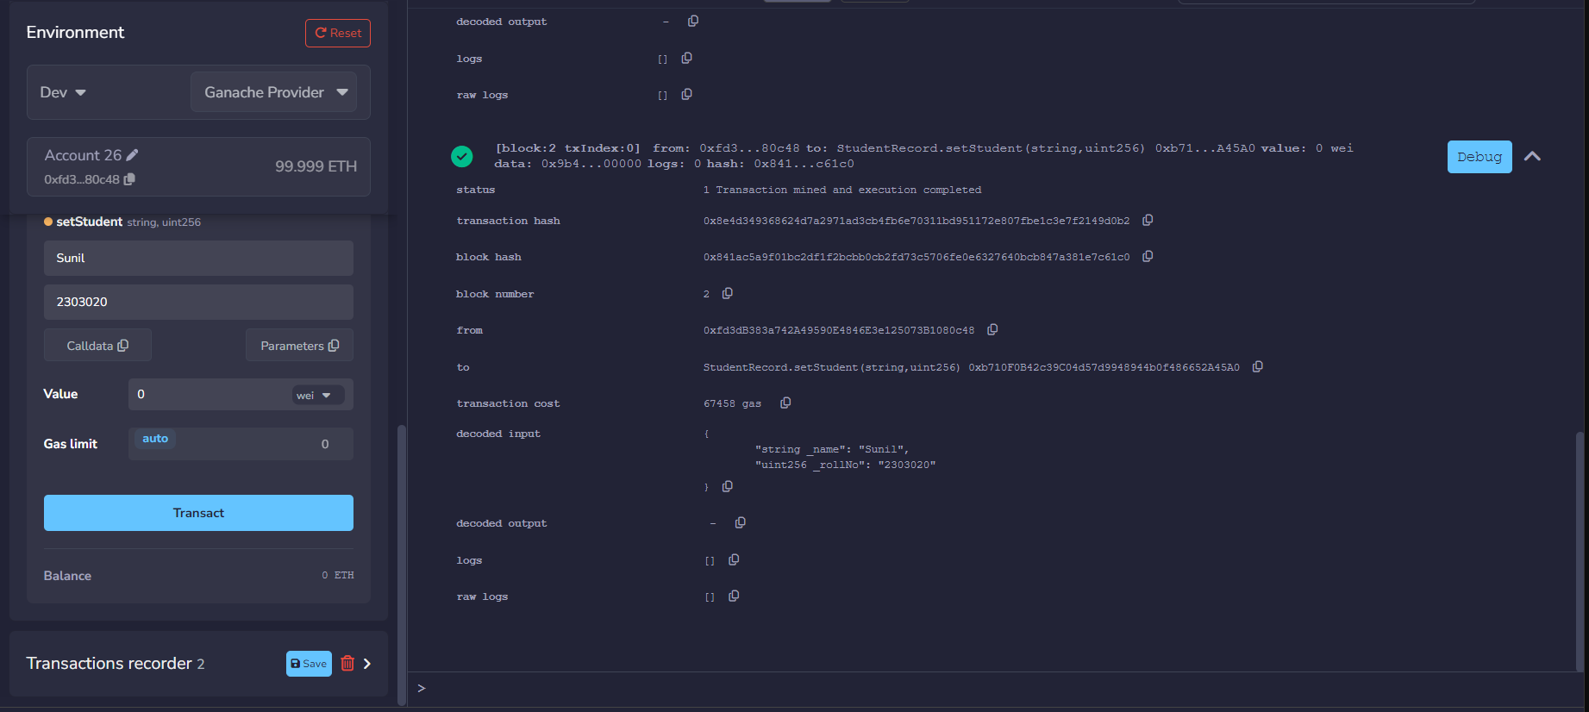

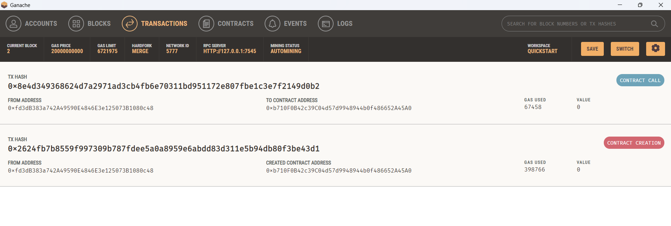
getStudent Function call
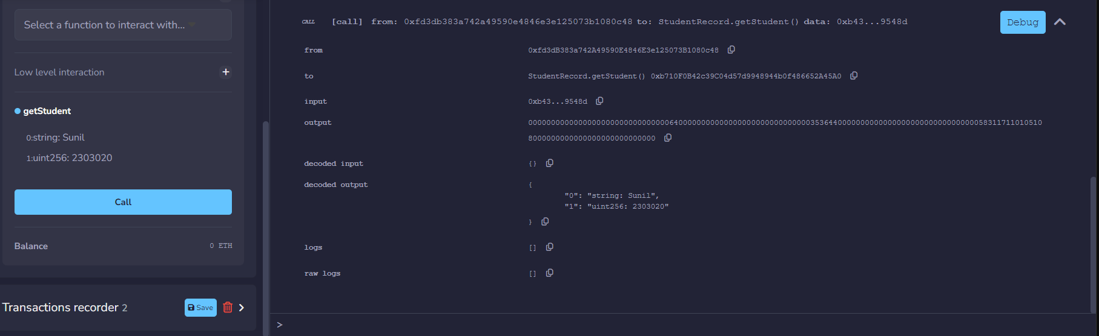
2)
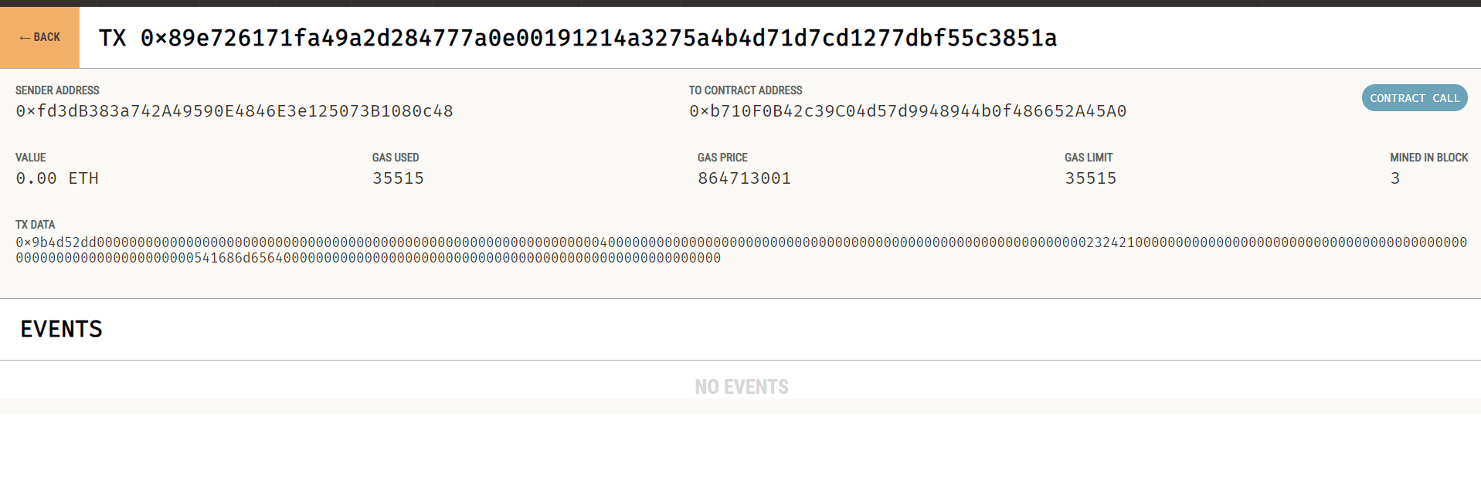
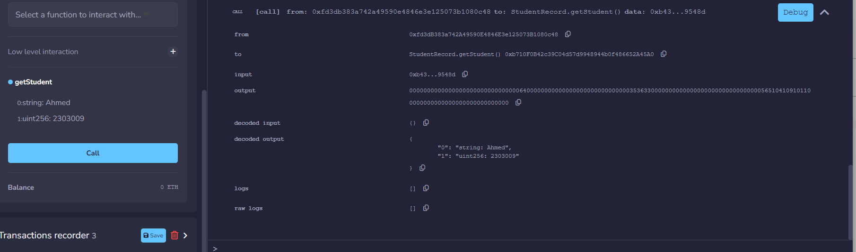
3)
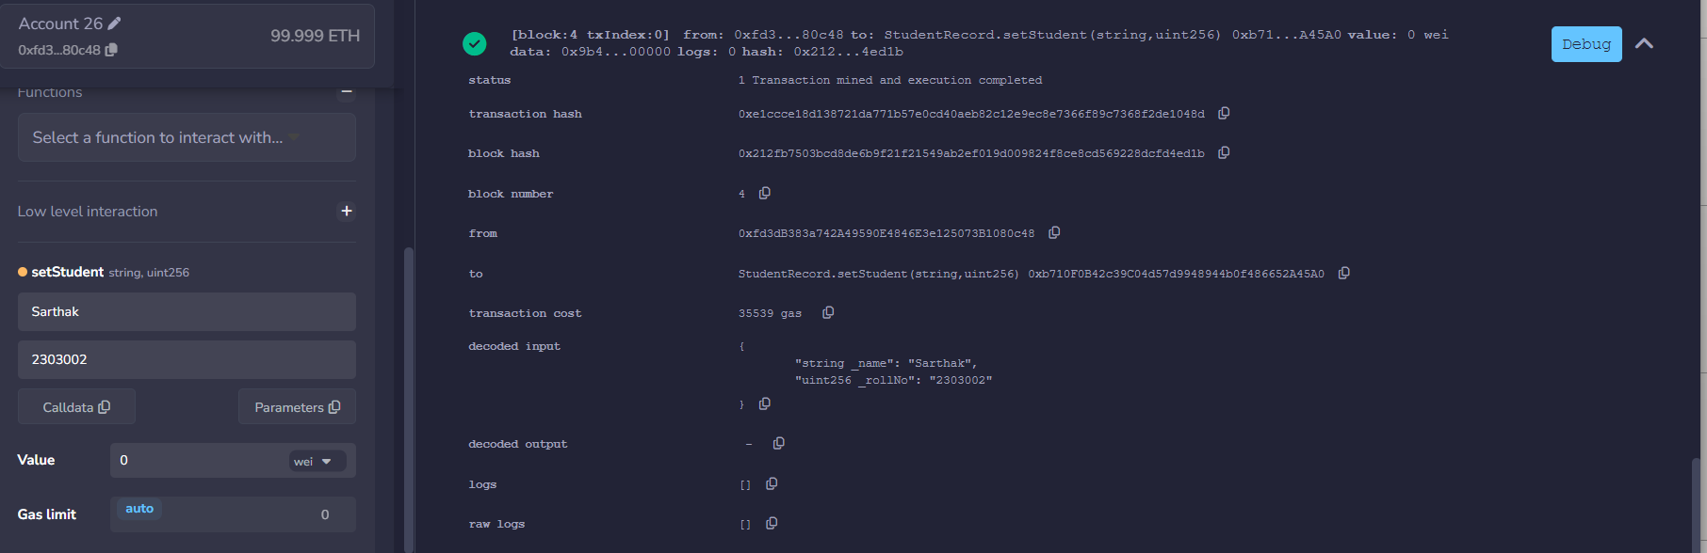
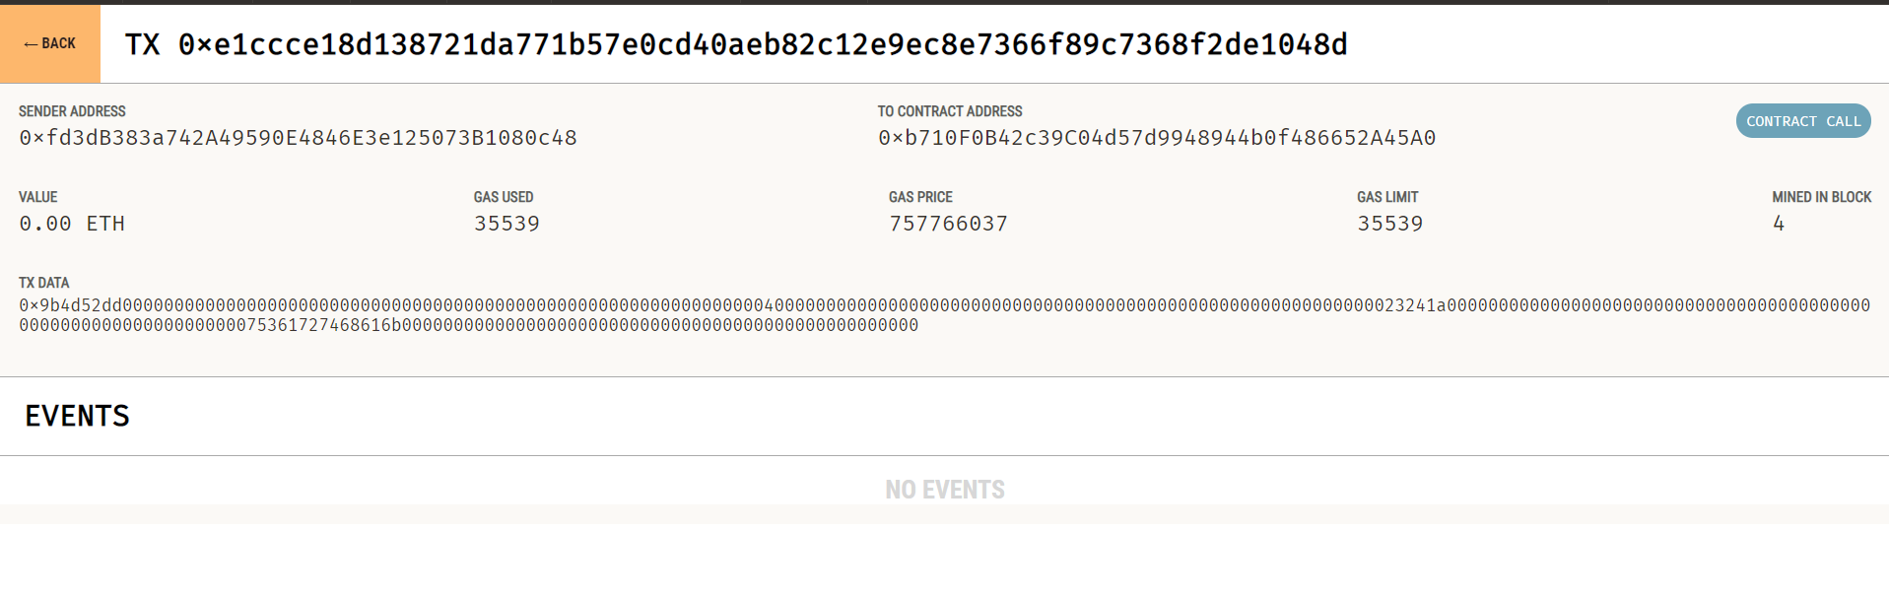
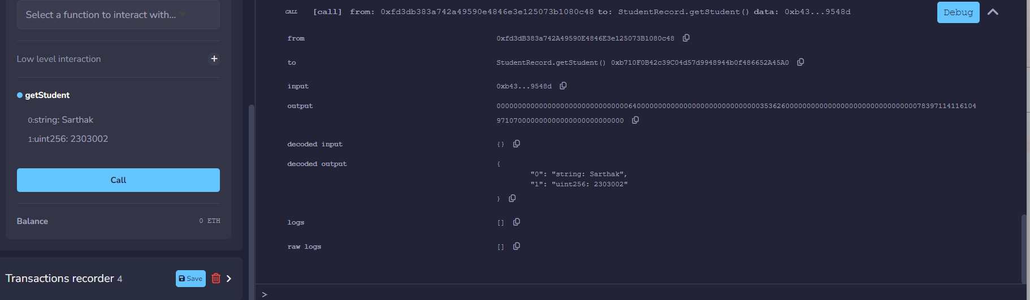

4)
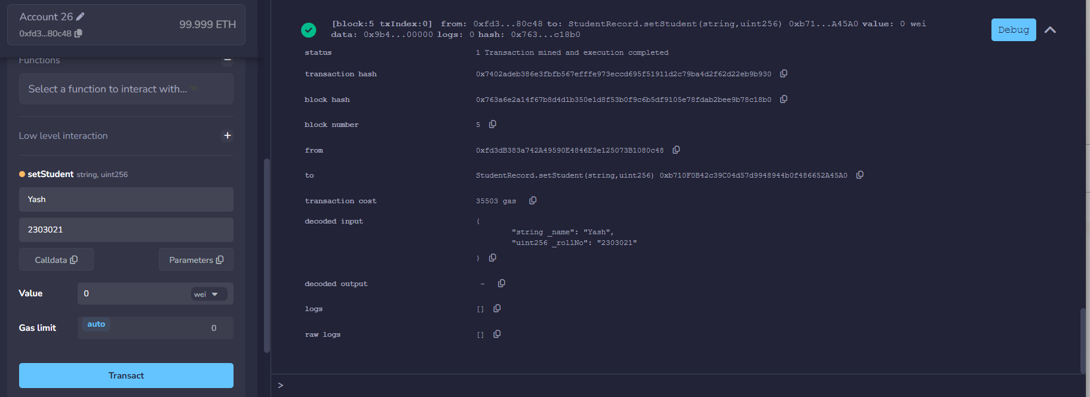
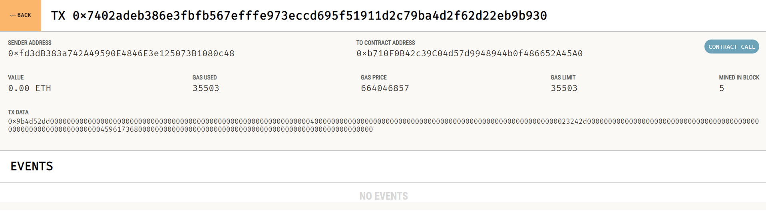
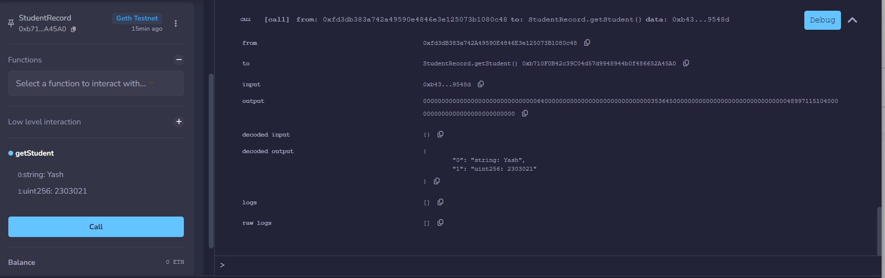

Transacrtions:
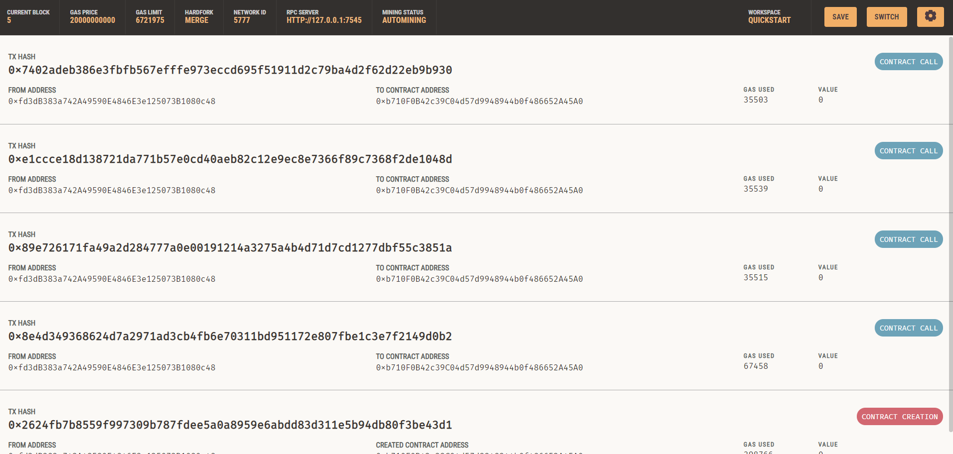

Account with transaction count
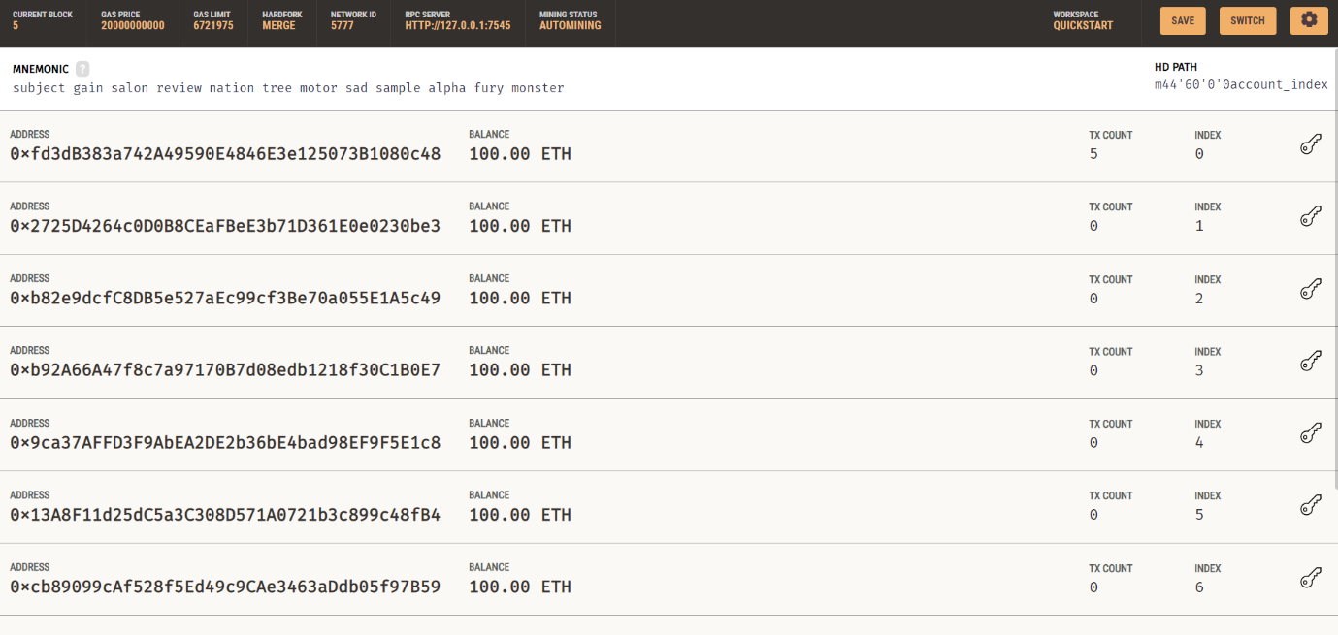

Blocks
